ST10451863

Kgothatso Masubelele

WEBDE5020-POE-Part 1

Website Choice 2

Website assets 3

Website Pages and Content 3

# Website Choice

My name is Kgothatso Masubelele a Varsity College Waterfall student that’s going to create and develop a POE website for an organization I think would benefit from my services.

The organization I have chosen is an organization that focuses more on the health and wellbeing of people in this world. FFICA (Fight Forward Cancer Institute) is an organization that helps people with anything cancer related, and it conducts research about cancer and make their findings available to the public. Its main goal and mission are to be able to save more and more lives daily that are being affected by cancer through the development of immunotherapies for all kinds of cancers people would have and providing those immunotherapies for free.

I chose this organization as a lot of people lack the necessary knowledge about what cancer is and how one could accrue it and how one can simply prevent from being infected with cancer. Through the POE website that I am going to create it will detail all the important information about cancer and how FFICA (Fight Forward Cancer Institute) can help those for face difficulties in finding help. My POE website will consist of a homepage where it will contain the navigation menu, a footer that will contain mainly the address of the organization, contact details, social media links and the T’s and Cs of the organization.

The POE website I will create will enable cancer-affected citizens to contact CRI to get help finding a treatment and possibly funding for it. The website I am going to create won’t be only helping people who have cancer but also help does who are not infected by providing information of what causes cancer and what one should do to prevent them from being infected by cancer. The website will also provide steps on what to do if you are someone who has just been infected by cancer.

This organization is one of the best in terms of helping people fight cancer and funding those who lack necessary funds for treatment and operations with vision is to create a more interactive POE website for FFICA (Fight Forward Cancer Institute)will enable more and more people to be aware of cancer and never lose hope on finding treatment due to lack of funds.

# Website assets

The website will have social media icon images of all meta platform and twitter/X. In summary the website will share the same header, footer and navigation throughout the website to make navigating the website seamless. Below are the images that will be found in the website:

Logo

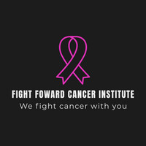

Social media platform icons

(x/Twitter)(Instagram)(Facebook)

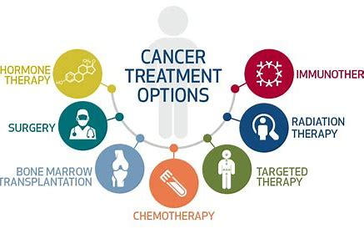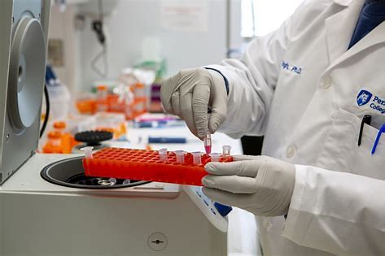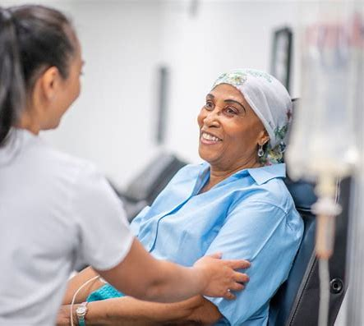

The images above are used to describe all the services that FFCI offers

Website Pages and Content

Homepage

The homepage of the website will include the name of the NGO, and its slogan followed by the NGO logo. The homepage will give a brief description of what cancer is and what causes it and how to prevent it. The homepage will have a 3 collum bar where the first collum is about awareness and education about cancer 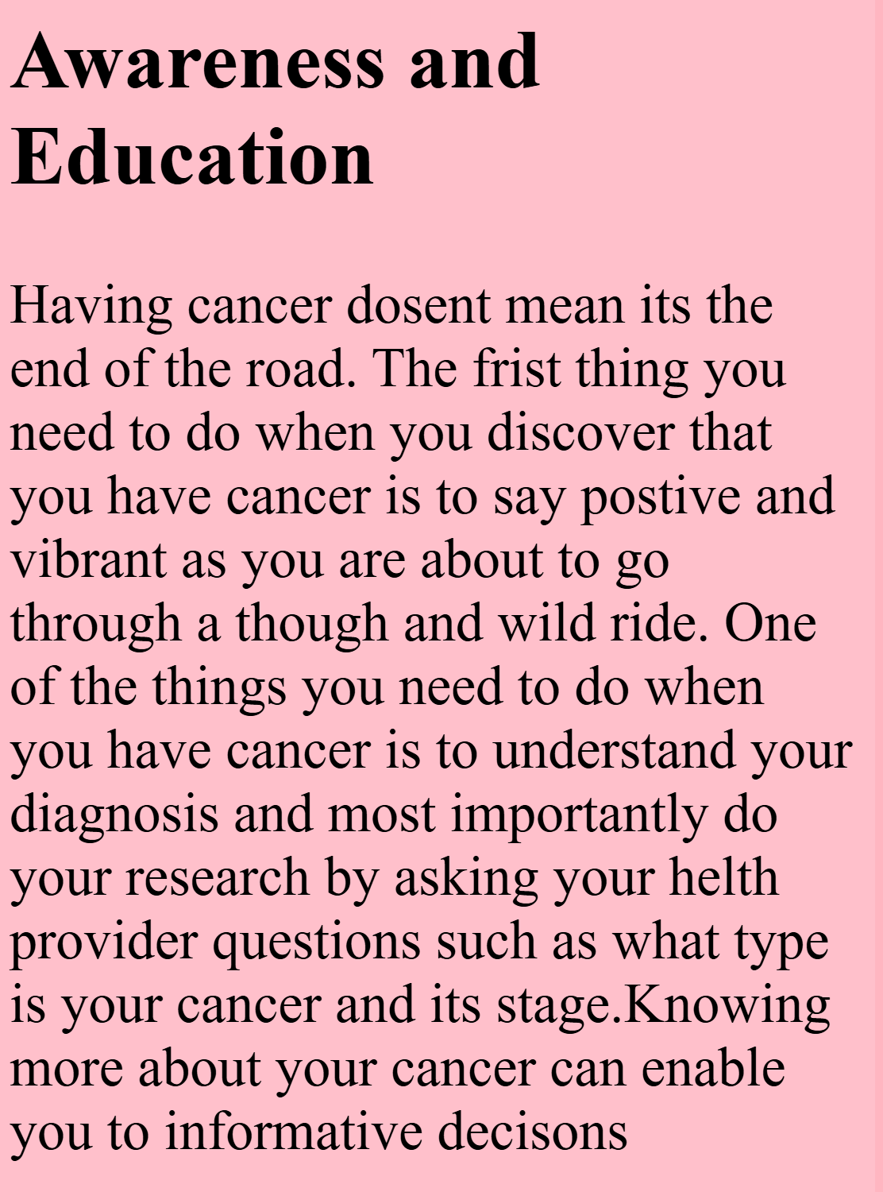

The second is a “Get Involved” column which details on how to get involved and participate or receive help from the campaign 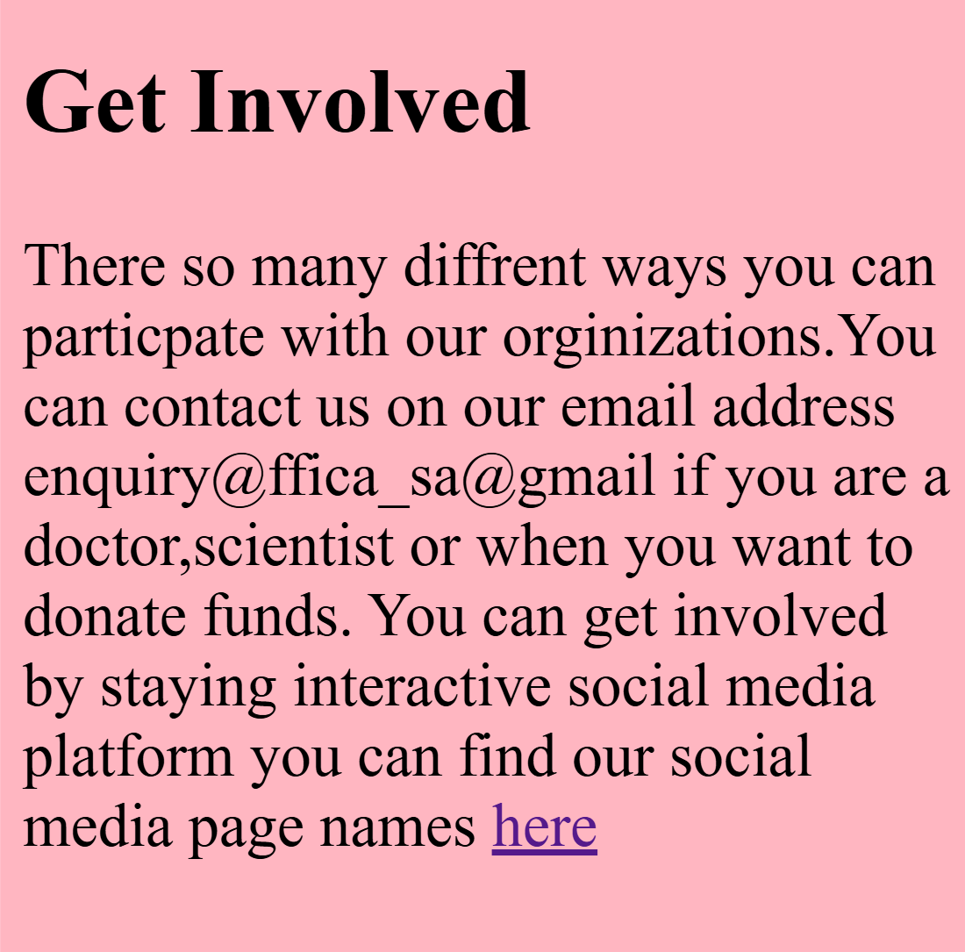

About us

The about us page gives a brief idea of what the NGO is all about and it outlines why the NGO does the work it does, and it will enable users of the website to be able to understand the background of the NGO

News

The news page will forecast new discoveries of new cancers and treatments. The news page will be used to forecast testimonies of satisfied patients we have helped to show case that indeed we all action not talk.

Product and Services

The product and service page will be used to outline all the products and services that Fight Forward Cancer Institute offers. This page will be used to give the website users an insight of the kind of benefits they will receive from the services and products we offer once their enquiry is approved

Contact us

The contact page is a page that will include all the organizations’ social media, and the organizations contact numbers and email addresses

Reference

WixLogoMaker. 2024. Logo-Maker. [Online]. Available at: [Wix Logo Maker](https://manage.wix.com/logo/maker/esh/brands/ff03c28e-2c10-448e-a8fd-ec59a941c75a/premium?industry2=%7B%22industry%22%3A%22__research%22%2C%22isCustom%22%3Atrue%7D&tags=creative%2Cformal%2Cfresh%2Ctimeless&referralAdditionalInfo=brandAiChatbot&plansTab=logo&plansType=allPlans&brandKitUpgradeFlow=false&designId=d46048d6-6dd0-49f7-948f-e52f624e2ce5&fromEditor=false)Accessed 10 August 2024].

w3schools. 2021. TryitEditor. [Online]. Available at: [W3Schools Tryit Editor](https://www.w3schools.com/howto/tryit.asp?filename=tryhow_css_three_columns) [Accessed 8 August 2024].

W3school. 2023.How to create a 3 column layout [Online]. Available at: [How To Create a Three Column Layout (w3schools.com)](https://www.w3schools.com/howto/howto_css_three_columns.asp) Accessed 5 August 2024].

StackOverflow, 2021. *Link HTML file with CSS file in Visual Studio*. [online] Available at: <https://stackoverflow.com/questions/69688588/link-html-file-with-css-file-in-visual-studio> [Accessed 15 September 2024].

Stack Overflow. (2009). *CSS: Positioning images next to text*. Available at: <https://stackoverflow.com/questions/1066188/css-positioning-images-next-to-text> [Accessed 20 Sep. 2024].

# Improvements to part 1

This file will contain a standard screen layout for all my screens making the layout of my screens consistent. To make my screen header look more appealing I changed my header style fromA screen shot of a computer code

to

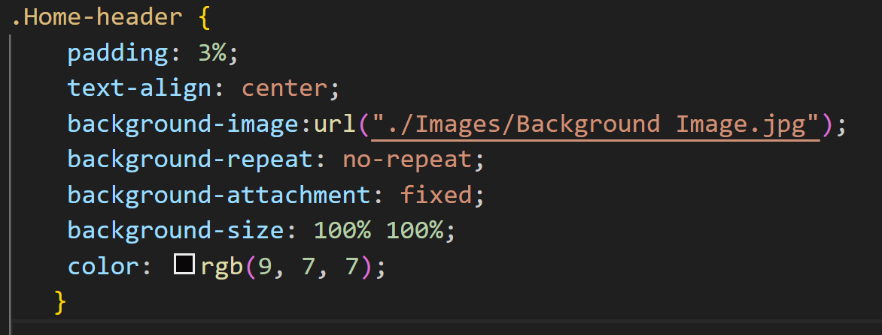

To make it more appealing and welcoming. I applied appropriate percentages (%) to the design to make it adaptive and scalable on certain css styles and removed pixels (px) which made my website lack flexibility in responsive layouts. To make my header, side navigation and footer to look more natural and to blend in together I made them to have the same background colour which is light pink. When it's comes to the changes I made in my homepage it's that I have added a YouTube video 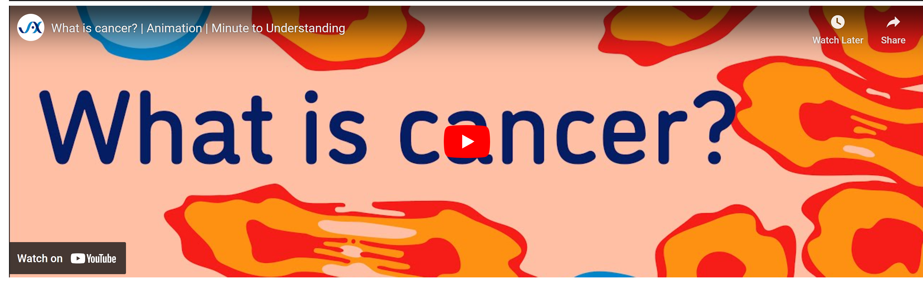

that explains what cancer is and have made the logo of FFCI much bigger and to align with the header of the page. I have recognized my code to display texts differently. I have fixed the broken links to other pages which were caused by syntax error where I coded <a href="Product and Service> instead of <a href=Product and Service.html>



On my About Us page changed my page link code which had a syntax error of <a href=”contact Us.html> instead of 

On my Product and Service page I changed the way I structed the services offered by FFCI and added an explanatory image to each service that’s offered by FFCI which is written in code as 